Nombre: ____________________________ Bloque: ________ Fecha: _______________________
Espanõl 2 - Unidad 5 – La cultura – España
Instrucciones: Fill out the following notes sheet based on the cultural activities online. This follows the online activity in order by section. Make sure to hold on to this paper to study, as this information will be part of the exam! This can also be used as a backup should you lose internet connection while working.

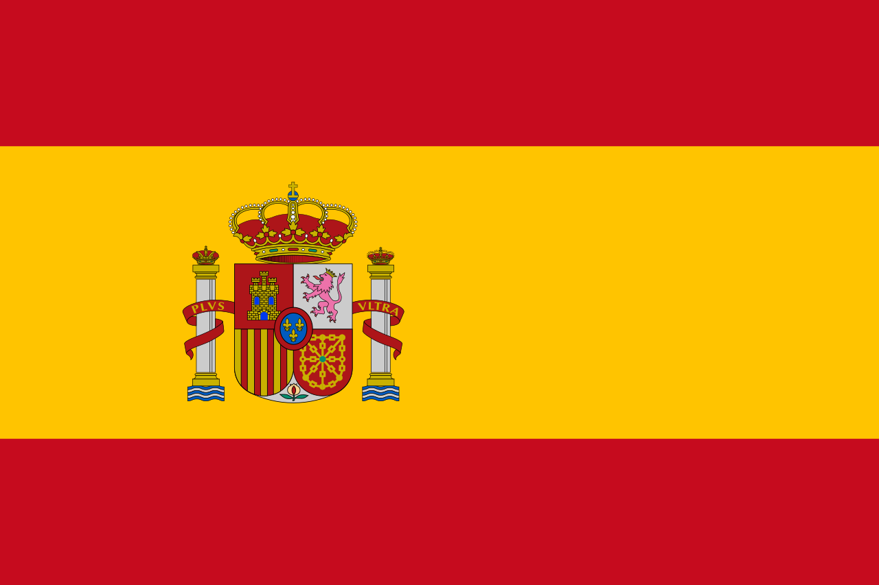
Datos generales y geográficos:
Colors/Design of the Spanish Flag: ________________________
________________________

- Capital of Spain: ____________________________
- Currency: ____________________________
- Typical Foods: _______________________________________
- Languages:___________________________________________
- 2 Cities in Andalucía: __________________________
- City in Cataluña: ________________________________
Churros y porras:
- Churros and porras, both types of fried dough are sold in ______________________.
- People often also get a _________________________ (caliente) drink that is very thick/rich and served with the churros or porras.
El Greco:
- El Greco was the nickname of Doménikos Theotokópoulos, born in ____________________________, but who became a famous artist in Spain.
- El Greco lived for many years in _________________________, Spain which is near Madrid.
- A famous painting by him is Vista de Toledo.
Antoni Gaudí:
- Antoni Gaudí was a famous catalán architect (arquitecto) from ________________________, Spain.
- Gaudí was a modernist and built decorative buildings and locations in Barcelona, drawing inspiration from ________________________ with bright colors and curving shapes.
- Some of Gaudí's famous works include: Casa Batlló, La Sagrada Familia, and ______________________.
La naturaleza muerta:
- La naturaleza muerta means __________________________.
- La naturaleza muerta paintings contain _____________________, and things such as flowers, fruits, foods, plates, utensils, bread and instruments.
- Àngel Planells was an artist from __________________________, Spain, and painted the above example of naturaleza muerta (a table with foods, a plate, glass, knife, napkin, etc).
Las tapas:
- Tapas are _____________________________ and are very common in Spain.
- Common tapas dishes include aceitunas (olives), el jamón, los calamares (squid) y los pulpos (_________________________).
- Another common tapa is la ensaladilla rusa, which is a mix of __________________________, carrots, peas and mayonnaise.
- Another common tapa la torilla de patatas (tortilla española) which is _____________________ than tortillas from Mexico/Central America. A tortilla española is made with egg, potatoes and onion. A tortilla mexicana is made of flour or corn.
Typical Spanish Dishes:
- Paella is a traditional rice dish originating from ________________________, Spain and is usually made with saffron, chicken, and shellfish.
- ______________________ is a cold soup made of tomatoes and raw vegetables blended together.
- ______________________ is a dessert custard served with a caramel sauce.
Pablo Neruda:
- Pablo Neruda was a famous poet from _________________________.
- Pablo Neruda wrote many _____________________________ to various every day objects (las cosas más básicas de la vida).
Maria Blanchard:
- María Blanchard was a famous Spanish painter (pintora) who also taught ___________________________.
- Common themes of Maria Blanchard's work were ___________________________.
- She used the money from the sale of her paintings to help ________________________.
Las horas de comer:
- In Spain, many people eat a _______________________ breakfast between 7 and 9 am.
- They eat a ___________________________ lunch between 1:30 and 3:30pm. Then may have a snack later between lunch and dinner.
- In Spain, many people don't eat ____________________________ until 9 or 10 at night.
- In Spanish-speaking countries such as Spain, El Salvador and Uruguay, ________________________ is the main meal of the day.
- People in El Salvador generally eat dinner _______________________ than people in Spain.

Toledo:
- Toledo, the capital of the province of Castilla-La Mancha is a historical city that has been protected since 1941 to ____________________ modernization and industrial development.
Culinary Traditions:
Cultural Comparison – Madrid, Spain:
- El cocido madrileño is a dish/stew from Madrid, Spain made from ______________________ (garbanzos), vegetables, and meats. When served, the stock/soup, vegetables/chickpeas, and meats are all served separately.
- Sobrino de Botín is a restaurant in Madrid, Spain that serves traditional platos madrileños and is famous as the ______________________ restaurant in the world.

Cultural Comparison – Montevideo, Uruguay:
- Montevideo, the capital of Uruguay is located on the coast so ______________________ are alimentos básicos (basic foods) of the region and easy to find.
- ____________________________ is a typical barbecue dish of meat roasted on a grill from the area of Montevideo.
- El Mercado del Puerto in Montevideo is a place you can go to ____________________________ as it houses a number of different restaurants.

